Term Four | ALL CREATURES GREAT AND SMALL
Term Four | 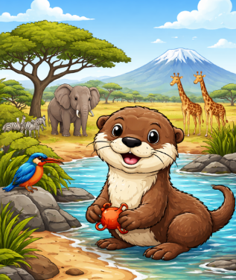  This term is going to be a wild adventure as we dive into our exciting new topic: All Creatures Great and Small We will be travelling across the world in our learning as we compare life in the United Kingdom with life in South Africa, making lots of links between Geography and Science along the way. Using atlases, globes and world maps, the children will become mini explorers as they locate both countries and discover which continents they belong to. We will talk about what each place might be like, thinking about weather, landscapes and, of course, the amazing animals that live there. We will be learning all about different types of animals. The children will identify and name a variety of common animals including fish, amphibians, reptiles, birds and mammals. We will look closely at their features and spotting similarities and differences. Why do birds have wings? What makes a reptile different from a mammal? How are pets similar to wild animals? These are just some of the questions we will explore together.

VALUE OF THE TERM: | CURIOSITY |  | PLAY PROJECTS: | CONSTRUCT COMPOSE CALCULATE CREATE
PE DAY: | TUESDAY AND FRIDAY |  | LIBRARY & READING  BOOK CHANGE: | MONDAY

FREQUENTLY ASKED QUESTIONS
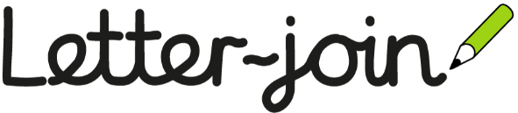  Where can I find my child’s handwriting log-in?  At school, we follow ‘Letter-join’ handwriting scheme. If you wish to practice letter formation or tricky words at home you can find the login below.  We request that you only use your child’s year group log-in as this is tailored to match our learning at school.  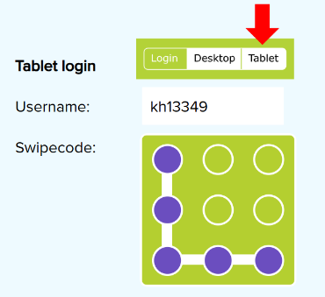  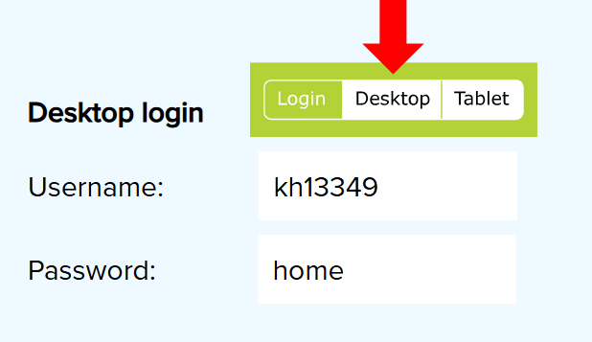 | When should I read with my child?  Reading at home can have a huge impact on children’s progress, as well as encouraging them to read for pleasure.  Children should read to you as many times as possible.  Please don’t forget to read to your child their library book or a book from home as this is a great way to discuss new vocabulary and develop a pleasure for reading.  When your child reads to you, don’t forget to sign in your child’s reading record.  We thank you for your support.

Learn Together | Mathematics | English
In Learn Together, we will be exploring the themes of ‘making a difference’ and ‘environment’.  We will be learning to:  - explore the school’s immediate environment; engaging in research and discussion around environmental issues in our locality e.g. plastic pollution or litter.  - identify and communicate ways to address these environmental issues e.g. reduce single use plastic in the classroom, recycle, use the food waste bins etc.  This term will focus on the following rights:  ARTICLE 12: You have the right to give your opinions freely on issues that affect you. Adults should listen and take you seriously.  ARTICLE 13: You have the right to share freely with others about how you feel, what you have learnt and think through discussion, drawing, writing or in any other way unless it harms other people.  ARTICLE 24: You have the right to the best health care possible, clean water to drink, healthy food and a clean and safe environment to live in.  ARTICLE 29: Your education should help you to fully develop your personalities, talents and abilities. It should teach you to understand your rights, and to respect other people’s rights, cultures and differences. It should help you to live peacefully and protect the environment. | Below is an outline of the concepts learnt in mathematics this term.  These may be altered where necessary.  Place Value (within 50)  - To count forwards and backwards within 50.  - To understand the ‘tens’ and ‘ones’ structure of numbers.  - To compare numbers.  - To order numbers.  - To count by making groups of tens.  - To partition into ‘tens’ and ‘ones’.  - To add and subtract by partitioning into tens and ones.  - To order on a number line.  - To estimate on a number line.  Length & Height  - To compare lengths and heights.  - To measure length using non-standard units (objects).  - To measure length in centimetres.  Your child could use the White Rose 1-minute application to practice number facts at home: https://whiterosemaths.com/1-minute-maths  Number Sense  In our daily Number Sense sessions, we will be focussing on using our ‘Five and A Bit’ hands to solve related addition and subtraction calculations.  For example :  8 shown as 5 fingers and 3 fingers helps us to solve:  5 + 3 = 8 3 + 5 = 8 8 – 3 = 5 8 – 5 = 3.  Note: When we use ‘Five and A Bit’ hands, we should be able to subitise (instantly see) the answers rather than count the total fingers. | 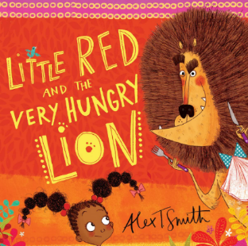  Across the term, we will be looking at our focus text ‘Little Red and the Very Hungry Lion’ by Alex T Smith. This book is a funny twist on the original Little Red Riding Hood tale except Little Red is walking in Africa and will come across crocodiles, giraffes and lions on the way to visit her poorly aunty!  Our focuses in writing this term will be on:  Alongside these, we will be aiming to write for more sustained periods producing a series of sentences that begin to consistently include capital letters, full stops and finger spaces. We will also continue to explore using alternative ‘phase five’ graphemes to spell with increasing accuracy.  We will also be aiming to spell the following tricky words* correctly:  again, any, ask, call, could, different, friend, many,  Mr, Mrs, people, school, should, their, two, water,  want, who, whole, work, would  *please note that tricky words cannot be sounded out and must be remembered.
  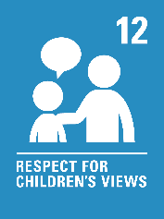 | 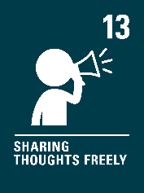 | 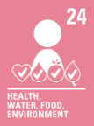 | 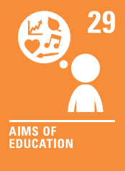
  Five and A Bit Hands
  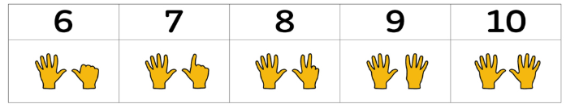
   | 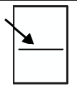 |  | 
  letter formation. | positioning our letters on the line. | using correctly sized letters. | saying our words aloud to check for any missing sounds.
  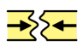 | 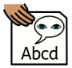 | 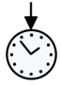 | 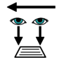
  using ‘and’ to join our ideas and sentences. | using adjectives | using present tense. | reading our work with a focus on editing and improving our work.
Art – Music and art | Computing – Data and Information | Geography- Similarities and difference (non-European country)
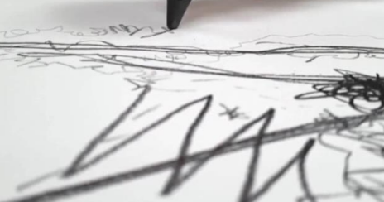  In Music, we will be introduced to the idea that artists often work in partnership and are often inspired by other art forms – in this case music and the visual arts. Children explore how other artists have used sound to inspire their artwork, and then go on to experiment with how they can use their mark making skills to both be influenced by, and to capture, the expression in music.  Your child will be learning to;  • explore how artists are inspired by music and share my ideas.  • listen to sounds and respond through mark making.  • draw while listening to music and let it inspire me.  • create imaginative instruments through drawing or construction.  • share and reflect on my work, listening to others’ responses. | In computing, we will begin to understand that labelling, grouping and searching are a common operation in many applications.  Your child will be learning to;  - count, describe and group objects in different ways.  - identify labels for grouped objects.  - compare groups of objects by describing their properties.  - understand that objects can be grouped in more than way.  - decide how to group objects to answer specific questions.  record and share data; understanding that it can be presented in different ways. | This term we will be comparing he UK and South Africa, linking closely to our animals topic.  We will start by asking the question: Where is South Africa on a map? We will use world maps and globes to locate both the United Kingdom and South Africa, learning about continents and noticing how far apart the two countries are.  We will be exploring aerial photographs and different types of maps to help us recognise and name human and physical features such as mountains, rivers and beaches, and human features such as roads, houses and schools. We will be using simple compass directions to describe the locations North, South, East and West. To help us remember these we will be using the mnemonic ‘Naughty Elephants Spray Water’.    We have also think about similarities and differences between the two countries, especially natural features and landscapes.
Science – All about animals (Y1) | Physical Education- Dance | Music – Composing
In Science, we will be biologists, discovering the animal families. We will observe and compare these closely to identify similarities and differences between each family.  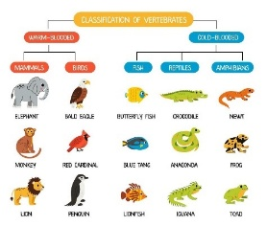  Your child will be learning to;  - identify and name a variety of common animals including fish, amphibians, reptiles, birds and mammals.  - describe and compare the structure of a variety of common animals (fish, amphibians, reptiles, birds and mammals, including pets).  - identify and name a variety of common animals that are carnivores, herbivores and omnivores. | 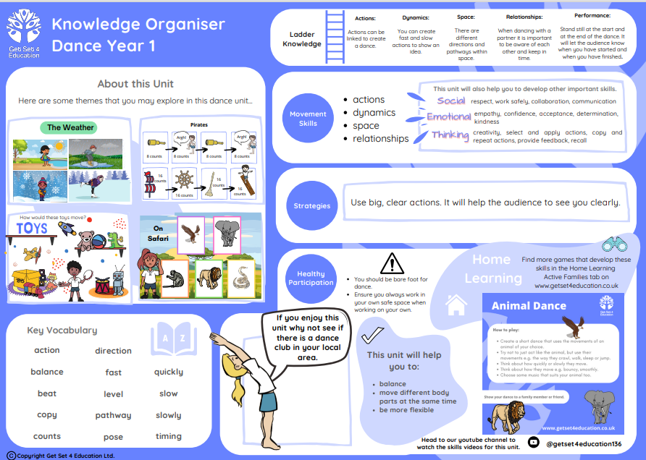 | In music, we will be continuing to give the children opportunities for expressive music making through composition where they will create and combine sounds and then use of different ways of pictorially recording them.  Your child will be learning to:  • Devise rhythms on untuned instruments.  • Improvise vocal chants.  • Create rhythm and pitch patterns.  They will also continue to:  • sing songs with increased vocal control, responding to visual directions and counting in.  • understand basic musical structures (rhythm, pulse, pitch, timbre and texture).  • think critically about music we have heard.

Supporting your child at home
Below you will find some optional ways to support your child at home:
Mathematics | Phonics & Reading
At school we are learning about our ‘Five and A Bit’ hands. We will be using these to solve related addition and subtraction calculations. Below are some simple activities you could complete at home to support this.  Match my fingers  - Hold out between six and ten fingers using ‘Five and A Bit’ hands (seen above).  - Ask your child to copy the pattern with their hands.  - Ask them, “How many fingers are you showing?”  - Summarise your fingers but saying “We are showing ___ fingers. ___ on this hand and ____ on this hand.”  Shout the number!  - On the count of 3, both you and your child show between six and ten fingers using your ‘Five and A Bit’ hands (shown above).  - Have you shown the same amount as each other?  If so, the first to shout the number you’ve both shown gets a point. Each time you match, talk about the number you have shown by saying “We are showing ___ fingers. ___ on this hand and ____ on this hand.”  White Rose 1-Minute Maths  White Rose provides a ‘1-Minute Maths’ application that can be used to practise addition and subtraction number facts at home. You can download this application scanning these QR codes or via: https://whiterosemaths.com/1-minute-maths | You can use the link or can the QR code below to find a wide range of information and videos to support your child with their reading and/or Phase 2, 3 and 5 sounds.  For parents | Letters and Sounds (littlewandlelettersandsounds.org.uk)  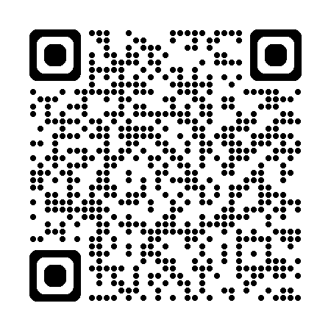  Your child should read their Little Wandle book to you at least 3 times a week. The more your child reads the more fluent they will become. Please remember to record this in their yellow reading record.
  Scan to download 1-Minute Maths |  |  |  | Maths with Michael
   | App Store |  | Google Play | Website
  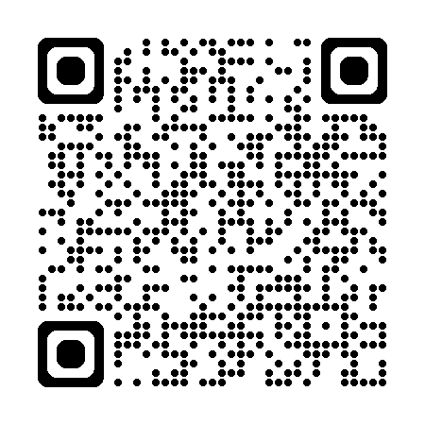 |  | 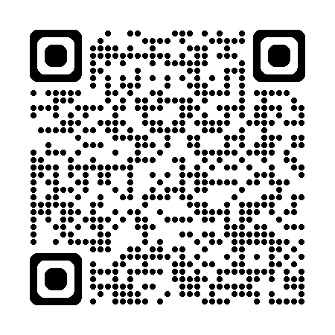 |  | 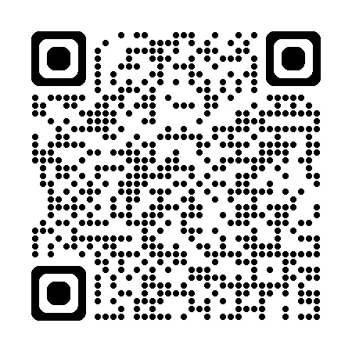
 | Handwriting
This term we are going to focus on some of our ‘zig zag letters'.

 | v  “Start on the dot, slope down, then slope up”
w
“Start on the dot, slope down, slope up, slope down, then slope down.”
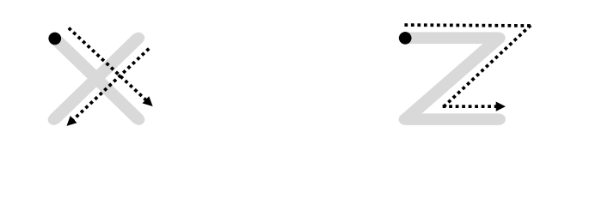 | x  “Start on the dot, a short slope down, lift your pencil, short slope down the other way”
z
“Start on the dot, a short line across, slope down, then back along the bottom”

You child could practice their handwriting using their pupil log-in to Letter Join.
Their class login can be found in the back of their child’s yellow reading record.
This application could be used to practice letter formation or tricky words.

