Term Three | Term 3- The wonderful world of water
Term Three |   This term promises to be full of adventure, creativity, and discovery! In History, the children will be learning about Grace Darling, a brave heroine whose courage and quick thinking saved lives at sea. We will explore her incredible story and think about why people still remember her today. Through this, the children will reflect on the qualities that make someone truly remarkable and heroic. In Science, we will become young investigators, exploring the world of everyday materials. The children will discover why some materials are perfect for certain jobs while others are not, testing and experimenting to see how materials behave in different situations. In Art, the children will experiment with different paint techniques to create exciting and colourful backgrounds. These artworks will then become the foundation for their lever projects in DT, combining imagination with practical skills to build working mechanisms.

VALUE OF THE TERM: | PERSERVERANCE |  | PLAY PROJECTS: | CONSTRUCT COMPOSE CALCULATE CREATE
PE DAY: | TUESDAY & FRIDAY |  | LIBRARY & READING  BOOK CHANGE: | MONDAY

FREQUENTLY ASKED QUESTIONS
What should my child wear on PE Days?  As Tuesday and Friday are our PE day, your child should be wearing:  - a white t-shirt  - black joggers or leggings  - trainers  - Any earrings taken out or covered | What does my child need to bring into school every day?  Your child needs:  - a bookbag containing their yellow reading record and reading book  - water bottle  On Monday, they will also need their library book. | When should I read with my child?  Reading at home can have a huge impact on children’s progress, as well as encouraging them to read for pleasure.  Children should read to you as many times as possible.  Please don’t forget to read to your child their library book or a book from home as this is a great way to discuss new vocabulary and develop a pleasure for reading.  When your child reads to you, don’t forget to sign in your child’s reading record.  We thank you for your support.

Learn Together |  | Mathematics |  | English
In Learn Together, we will be exploring the theme of Health and Hygiene  Children will be learning about what it means to be healthy and why looking after their bodies is important. Through discussion and practical activities, they will explore how everyday choices help keep themselves and others well.  Children will learn to:  - Understand what being healthy means and why it matters  - Explore simple daily self-care routines  - Learn basic hygiene practices, such as hand washing  - Begin to understand that everyone has a responsibility to help reduce the spread of infection  - Develop simple skills to help prevent illness spreading  - Learn about physical activity and how it supports a healthy body  - Talk about different types of play, including indoor, outdoor and screen-based play, and the importance of balance  - Identify people who help them stay healthy, such as parents, doctors, nurses, dentists and lunch supervisors  - Learn how to keep safe in the sun  - Internet Safety  This term will focus on the following rights:  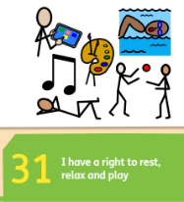  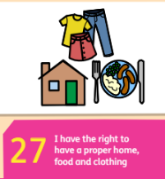 |  | Below is an outline of the intended progression of learning in mathematics this term. It may be altered where necessary.  Place Value (within 20)  Week 1:  - To count forwards and backwards within 20.  - To understand the ‘ten and a bit’ structure of numbers.  Week 2:  - To understand the structure of numbers within 20.  Week 3:  - To understand 20.  - To find 1 more and 1 less.  Week 4:  - To order on a number line.  - To add on a number line.  Week 5:  - To subtract on a number line.  - To estimate on a number line.  Week 6:  - To compare numbers.  - To order numbers.  Your child could use the White Rose 1-minute application to practice number facts at home: https://whiterosemaths.com/1-minute-maths  Number Sense  In our daily Number Sense sessions, we will be focussing on these mental strategies of calculation:  Once we have secured these, we will apply these when calculating the addition and subtraction of 1 and near double calculations. |  | Across the term, we will be looking at two focus texts. The first focus text is ‘The Pirates Next Door’ by Jonny Duddle. We will use this focus text as inspiration to write a range of character descriptions. Our second text is ‘The Odd Fish’ by Naomi Jones. We will use this book to create a non- chronological report.  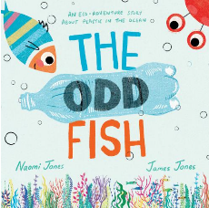  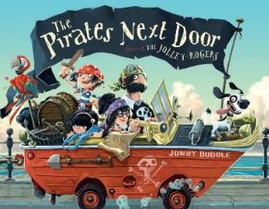  Our focuses in writing this term will be on:  Alongside these, we will be aiming to write for more sustained periods producing a series of sentences that begin to consistently include capital letters, full stops and finger spaces. We will also continue to explore using alternative ‘phase five’ graphemes to spell with increasing accuracy.  We will also be aiming to spell the following tricky words* correctly:  again any beautiful busy call  could different eye friend laugh  people pretty their should two  whole work would your  *please note that tricky words cannot be sounded out and must be remembered.
  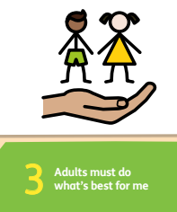 | 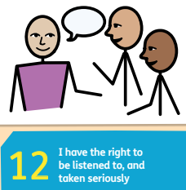 | 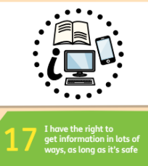 | 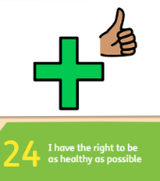
  One More | One Less
  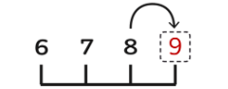 | 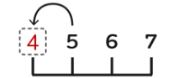
  “One more is always the  next counting number” | “One less is always the  counting number before”
   |  |  | 
  letter formation | positioning our letters on the line. | using correctly sized letters. | saying our words aloud to check for any missing sounds.
   |  | 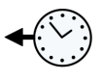 | 
  using ‘and’ to join our ideas and sentences. | using adjectives | using simple past tense. | reading our work with a focus on editing and improving our work.
Art- Expressive Painting |  | DT – Mechanisms: Sliders |  | Computing – Programming A Robot
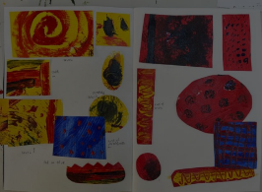  In art, children will explore painting in a fun and creative way. They will learn that painting does not have to look realistic and that it is okay to experiment and try new ideas.  - Children will look at paintings by different artists and notice how they use colour, brush marks, and texture.  - They will explore primary and secondary colours by mixing paint and making expressive marks.  - We will try different painting techniques, including using thick paint and scratching into paint to create interesting textures.  - They will also look closely at paintings by artists to see how pictures are made using brushstrokes and layers of paint |  | In DT, we will be exploring mechanisms with a focus on sliders.  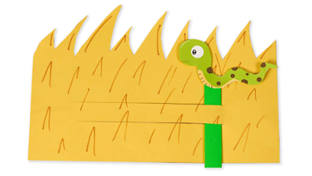  Your children will be learning to;  - understand that different mechanisms produce different types of movement.  - use a range of technical vocabulary including; slider, bridge and slot.  - explore and use a slider to design, make and evaluate a moving space image. |  | In computing, we will be learning to program robots and create algorithms.  Your child will be learning to:  - predict and run commands on a bee-bot.  - match a command to an outcome.  - understand that a program is a set of commands that a computer can run.  - combine a commands in a program by building a sequence in steps.  run a program on a bee-bot.
Science- Everyday materials |  | History- Grace Darling |  | Music – Composing
In science we will begin to explore everyday materials. We will begin to describe their simple physical properties and learn how to compare and group materials based on these.  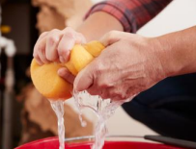  Your child will be learning to;  - distinguish between an object and the material from which it is made.  - identify and name a variety of everyday materials, including wood, plastic, glass, metal, water, and rock.  - describe the simple physical properties of a variety of everyday materials.  compare and group together a variety of everyday materials on the basis of their simple physical properties. |  | In history this term we are learning about Grace Darling, a significant historical figure known for her bravery and kindness. Grace Darling lived in the 19th century and became famous for helping rescue survivors of a shipwreck off the coast of England.  Your child will be learning:  - Who Grace Darling was and where she lived  - Why she is remembered as a hero  - The importance of bravery, helping others, and responsibility  - How historians use different sources to learn about the past  - How we can explore why Grace Darling acted as she did and how we know about her actions  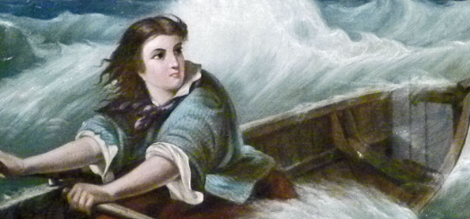 |  | In music, we will be giving the children opportunities for expressive music making through composition where they will create and combine sounds and then use of different ways of pictorially recording them.  Your child will be learning to:  - Devise rhythms on untuned instruments.  - Improvise vocal chants.  - Create rhythm and pitch patterns.  They will also continue to:  - sing songs with increased vocal control, responding to visual directions and counting in.  - understand basic musical structures (rhythm, pulse, pitch, timbre and texture).  - think critically about music we have heard.
Physical Education – Gymnastics
In this unit of PE, children will develop their balance, agility and coordination through a range of gymnastic activities. They will learn to control their bodies, work safely, and combine movements in creative ways, both independently and with a partner. This will include;  - Balancing  - Partner Balances  - Rolling  - Jumping  - Building Sequences | 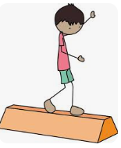

Supporting your child at home
Below you will find some optional ways to support your child at home:
Mathematics | Phonics & Reading
At school we are learning about the numbers 5, 6, 7, 8 and 9. We are learning the different ways that these numbers can be made up from smaller numbers. Below are some simple activities you could complete at home to support this.  One More, One Less  - Ask your child to lay out 0-10 number cards and place them from smallest to greatest.  - Choose a card e.g. 8  - Turn over the card before and after your chosen card.  - Ask your child to tell you the hidden numbers using the sentence stems: “7 is one less than 8” or “9 is one more than 8”  - Repeat the activity, swapping between choosing the card and saying the sentences.  How many?  You could build one more and one less into your daily routines.  For example:  - When playing with toys, ask your child “Please can you get me some bricks? I would like one more / less than 5”  - When eating, ask your child “Please can you get some spoons? We need one more / less than 2”  - When doing the washing, ask your child “Please can you help me hang up some t-shirts? We need one more / less than 6”  White Rose 1-Minute Maths  White Rose provides a ‘1-Minute Maths’ application that can be used to practise addition and subtraction number facts at home. You can download this application scanning these QR codes or via: https://whiterosemaths.com/1-minute-maths | Just like reception, in year one, we follow the Little Wandle phonics programme. Little Wandle have a tailor made section of their website to provide support and information to parents.  You can use the link or can the QR code below to find a wide range of information and videos to support your child with their reading and/or Phase 2, 3 and 5 sounds.  For parents | Letters and Sounds (littlewandlelettersandsounds.org.uk)    Your child should read their Little Wandle book to you at least 3 times a week. The more your child reads the more fluent they will become. Please remember to record this in their yellow reading record.
  Scan to download 1-Minute Maths |  |  |  | Maths with Michael
   | App Store |  | Google Play | Website
   |  |  |  | 
 | Handwriting
This term we are going to focus on some of our ‘one armed robots'.
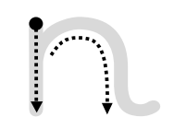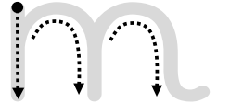   | n  “Start on the dot, go down, up and over, and hook”
m
“Start on the dot, go down, up and over,
up and over, and hook”
r
“Start on the dot, go down, back up, and curve”
k
“Start on the dot, go down, back up,
loop, kick, and hook”

