Term Two | Wonderful Weather

This term, the children will be learning about weather around the world, with a particular focus on hot and cold places. We will explore the different climates across the globe and discover how weather affects people, animals, and the environment in both tropical and polar regions. As part of our learning, we will also study the seven continents, comparing their climates and the ways living things adapt to different weather conditions. The children will use world maps, atlases, and globes to locate hot and cold areas of the world in relation to the Equator and the Poles.

We will also be observing seasonal changes, learning why we have different seasons and how these changes impact our daily lives. The children will observe and record daily and seasonal weather patterns in the UK, developing their skills in observation.

We are also very excited to take part in our Nativity performance this term — a wonderful opportunity to celebrate together and share the joy of the festive season!

VALUE OF THE TERM: | RESPECT |  | PLAY PROJECTS: | CONSTRUCT COMPOSE CALCULATE CREATE
PE DAY: | TUESDAY AND FRIDAY |  | READING BOOK CHANGE: | MONDAY

Learn Together | Mathematics | English
In Learn Together, we will be exploring the themes of ‘seasons’ and ‘feelings’.  We will be learning to:  - identify seasons and months within a year and discuss our favourite season.  - identify special events / celebrations during the year and discuss how some have a fixed date and others do not.  - talk about months and seasons where significant events happen in our lives such as birthdays, Easter, Diwali etc.  - Demonstrate an understanding of feelings such as sadness, happiness, anger, excitement etc. and identify these in stories, scenarios and in themselves.  - Demonstrate an understanding that all feelings are a normal part of human life and that feelings are transient not permanent.  - Recognise how feelings can affect how people behave.  - Explore how to manage and whom to tell when finding things difficult, or when things go wrong  This term will focus on the following rights:  ARTICLE 2: All children have all these rights and no child should be treated unfairly for any reason.  ARTICLE 8: You have the right to an identity.  ARTICLE 12: You have the right to an opinion and for it to be listened to and taken seriously.  ARTICLE 14: You have the right to think what you like and be whatever religion you want to be, with your parents’ guidance.  ARTICLE 29: You have the right to education which tries to develop your personality and abilities as much as possible and encourages you to respect other people’s rights and values and to respect the environment. | Below is an outline of the intended progression of learning in mathematics this term. It may be altered where necessary.  Addition and Subtraction  Week 1:  - To identify part and wholes  - To find a whole using a part whole model (Concrete)  Week 2:  - To find a whole using a part- whole model (Pictorial)  - To recognise addition is commutative  Week 3:  - To add more using tens frames  - To add more using a number line  Week 4:  - Addition word problems  - To find number bonds to 10  Week 5:  - To find a part using a part whole model (Concrete)  - To find a part using a part whole model (Pictorial)  Week 6:  - To subtract by taking away  - To subtract by crossing out  Week 7:  - To subtract on a number line  - Subtraction word problems  NumberSense  In our daily NumberSense sessions, we will be focusing on:  - Making and breaking 7 e.g. 7 – 6 = 1 or 1 + 6 – 7.  - Making and breaking 8 e.g. 8 – 4 = 4 or 4 +4 = 8  - Making and breaking 9 e.g. 9 – 5 = 4 or 5 + 4 = 9 | Across the term, we will be looking at the focus book ‘ One Snowy Night’ by Nick Butterworth. On a cold, snowy winter's night, Percy the Park Keeper is preparing to settle in for the evening in his cozy hut. But the freezing weather is too harsh for the animals outside. One by one, animals from the park—including a squirrel, fox, badger, hedgehog, and more—come knocking on Percy's door, seeking warmth and shelter.  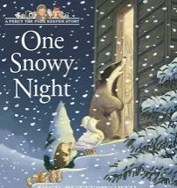  Initially, we will use this text as an inspiration to produce postcards in the role of Percy. We will conclude the term by planning and retelling the story making sure we have a clear beginning, middle and end.  Our focuses in writing this term will be on:  Alongside these, we will be aiming to write for more sustained periods producing a series of sentences that begin to consistently include capital letters, full stops and finger spaces. We will also begin to explore using learnt alternative spellings to spell with greater accurately.  We will also be aiming to spell the following tricky words* correctly:  all by come have here  like little my pure sure  there they today was what  when we you once  *please note that tricky words cannot be sounded out and must be remembered.
    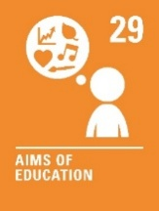 | 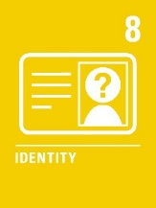 | 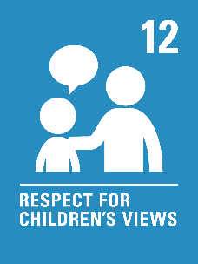 | 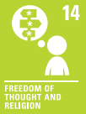
   | 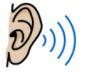 | 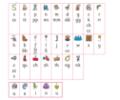 | 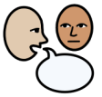
  Lowercase letter formation | Listening and using sounds to help us spell. | Using a sound mat to support our spelling. | Saying our sentence aloud to check it makes sense.
Art – Mono Print | Geography – World Geography | Computing- Digital Painting
In art, we will explore ‘our world’ and begin to develop an understanding of the concepts of Mono Print  Your child will be learning to;  - mark make to produce unique, one-off prints that capture the impression of a drawing.  - explore an artist that uses mono print in his work.  - use a range of marks so that we can create different visual effects and textures.  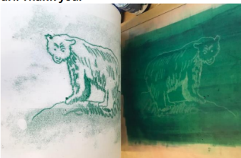  - respond to various stimuli to make creative and personal artwork that reflects our own interpretations and ideas.  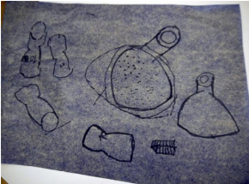 | In geography we will be exploring our world’s seven continents. We will be exploring through our study of extreme weather;   Your child will be learning to;  - Identify the 7 continents and the 4 seasons  - Where the hot and cold areas of the world are  - What the climate is like in England and a non-European country  - What extreme weather is and how it causes problems  - How the climate differs around the world | In Computing, we will begin to explore a variety of tools that can be used to produce digital paintings. We will be using the free website ‘PaintZ’ to curate digital paintings. You can visit this website via the link below or by scanning this QR code:  Your child will be learning to;  - identify, describe and use a range of shape and line tools.  - curate a digital painting independently.  - compare paintings produced on a computer with those produced on paper.
   | Visit PaintZ
Science – Seasonal change | Music – Nativity | Physical Education – Coordination & Static Balance
In science, your child will be learning to observe seasonal changes. These include the different weather conditions and changes in day length across the four seasons. We will be using and making a range of scientific tools (anemometers) and our five senses to make observations.  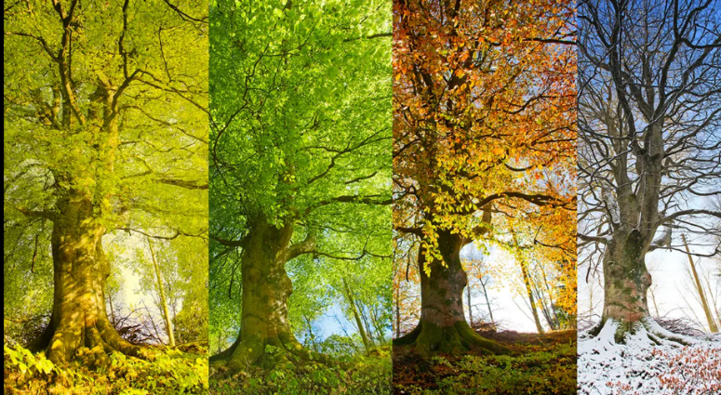 | In music, we will practising for our nativity play. We will be learning each song as well as the actions to match.  Our Nativity will be based on Rascal and Scamp the party sheep! When they see Bethlehem filling up, they assume it’s for a big celebration and they do not want to miss out! They escape from the flock and make their way into town, but although they find lots of things they love like noise and crowds of people, there is no party. However, what they do find is the nativity story unfolding right before their eyes, which gives everyone a reason to celebrate!  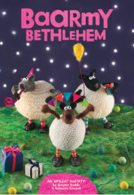 | Dynamic Balance to Agility: Jumping and Landing  Your child will be learning to;  - jump forwards and backwards on two feet, bending their knees as they land.  - jump from side to side, keeping their feet a shoulder width apart.  - jump with varying speeds, starting slowly and speeding up.  - jump and turn in a given direction, keeping their heads upright.  - jump from two feet to one foot, keeping their balance as they land.  Static Balance: Seated  Your child will be learning to;  - sit down and hold a balance, keeping their head upright and still.  - hold a seated balance for 10 seconds.  - move an object from one side of their body to the other whilst maintaining a seated balance.

Supporting your child at home
Below you will find some optional ways to support your child at home:
Mathematics | Phonics & Reading
At school we are learning about the numbers 5, 6, 7, 8 and 9. We are learning the different ways that these numbers can be made up from smaller numbers. Below are some simple activities you could complete at home to support this.  Finding numbers in everyday life  Look out for opportunities to make each of our focus numbers in everyday life. Perhaps your child has a box set of 7 books that you are reading together. “We have read 5 of them now. We still have 2 more to read.” You could also look out for opportunities to put things in sevens; even if you don’t have to! You could cut up snacks in 7 pieces and talk about how many are left e.g. “You had 7 grapes, you have eaten 2, you have 5 left.”  Simon Says  You could play ‘Simon Says’ with 7 actions each time (folding arms, patting head, blinking, hopping) When you say “Simon says jump 8 times”, your child follows the instructions. As they do each action, you can count together. But if you just say “Jump 7 times”, your child have to remember not to do it. Then give them a turn to give you instructions. Will they catch you out?  Find me!  Choose 7 items and hide them around a room. Your child needs to find each and bring them to you. Each time they bring one, discuss how many are left e.g. “You found 3 now, 4 more to go!”  White Rose 1-Minute Maths  White Rose provides a ‘1-Minute Maths’ application that can be used to practise addition and subtraction number facts at home. You can download this application scanning these QR codes or via: https://whiterosemaths.com/1-minute-maths | Just like reception, in year one, we follow the Little Wandle phonics programme. Little Wandle have a tailor made section of their website to provide support and information to parents.  You can use the link or can the QR code below to find a wide range of information and videos to support your child with their reading and/or Phase 2, 3 and 5 sounds.  For parents | Letters and Sounds (littlewandlelettersandsounds.org.uk)    Your child should read their Little Wandle book to you at least 3 times a week. The more your child reads the more fluent they will become. Please remember to record this in their yellow reading record.
  Scan to download 1-Minute Maths |  |  |  | Maths with Michael
   | App Store |  | Google Play | Website
   |  |  |  | 
 | Handwriting
This term we are going to focus on some of our ‘Long Ladder Letters’.
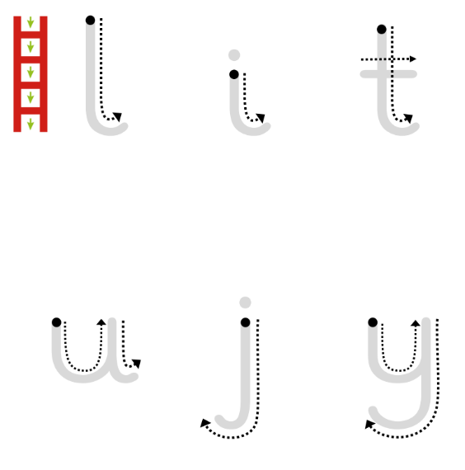 | l  “Start on the dot, go all the way down and hook”.
i
“Start on the dot, go down, hook and dot”.
t
“Start on the dot, go down, hook and cross the t”.
.

