Term Six | 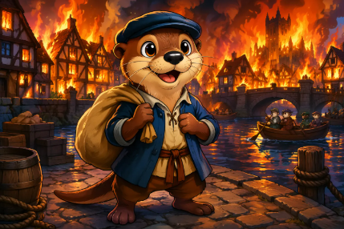  London  This term we will travel back in time to discover the story of the Great Fire of London and find out how a small fire became one of the most famous events in British history. We will become history detectives, investigating how and why the fire started, how it spread so quickly, and what happened to the people who lived in London at the time. We will also learn about Samuel Pepys and explore his diary to uncover clues about what he saw during the fire. In DT, we will become bakers as we design and make our own delicious bread. We will explore ingredients, learn how bread is made, and use our creativity to design products before tasting and evaluating our finished creations. Our geography learning will take us on a journey around the United Kingdom. We will discover the four countries that make up the UK—England, Scotland, Wales and Northern Ireland—and learn about their capital cities. Along the way, we will explore famous landmarks, uncover interesting facts, and develop our map skills as we investigate what makes each place special.

VALUE OF THE TERM: | HONESTY |  | PE DAY: | TUESDAY AND FRIDAY |  | LIBRARY & READING BOOK CHANGE: | MONDAY

FREQUENTLY ASKED QUESTIONS
What should my child wear on PE Days?  As Tuesday and Friday are our PE day, your child should be wearing:  - a white t-shirt  - black joggers or leggings  - trainers  - Any earrings taken out or covered | Where can I find my child’s handwriting log-in?  At school, we follow ‘Letter-join’ handwriting scheme.    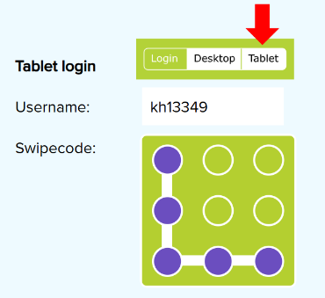  We request that you only use your child’s year group log-in as this is tailored to match our learning at school.  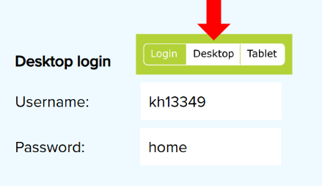 | When should I read with my child?  Reading at home can have a huge impact on children’s progress, as well as encouraging them to read for pleasure.  Children should read to you as many times as possible.  Please don’t forget to read to your child their library book or a book from home as this is a great way to discuss new vocabulary and develop a pleasure for reading.  When your child reads to you, don’t forget to sign in your child’s reading record.  We thank you for your support.

Learn Together | Mathematics | English
In Learn Together, we will be exploring the theme of ‘food’.  We will be learning:  - about balanced diets and thinking about our sugar intake.  - about what it means to be healthy and how different foods can help us to stay healthy.  - about how different cultures and traditions have their own culinary styles / approaches to food e.g. use of spices, use of chopsticks etc.  This term will focus on the following rights:  ARTICLE 6: You have the right to be supported that helps you to develop to your full potential.  ARTICLE 24: You have the right to the best possible health. Governments must provide good quality health care, clean water, nutritious food, and a clean environment and education on health and well-being so that you can stay healthy.  ARTICLE 29: You have the right to an education which tries to develop your personality and abilities as much as possible and encourages you to respect other people’s rights and values and to respect the environment. | Fractions  - To recognise a half and a quarter of an object or shape.  - To find a half and a quarter of an object or shape.  - To find a half and a quarter of a quantity.  Money  - To unitise coins.  - To recognise coins.  - To count similar coins in 2s, 5s and 10s.  Time  - To tell the time to the hour and the half hour.  - To draw time to the hour and the half hour.  Place Value (within 100)  - To count forwards and backwards within 100.  - To count in tens to 100.  - To understand the structure of numbers to 100.  - To order on a number line.  Number Sense  In our daily Number Sense sessions, we will continue to develop our knowledge of alternative names.  Across the term, we will use this knowledge to quickly partition numbers for adding and subtracting. For example: | 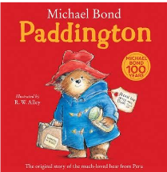  Across this term, we will be using the book ‘Paddington’ by Michael Bond to work on narratives…..  Our focuses in writing will be on:  Alongside these, we will be aiming to write independently for sustained periods producing at least five sentences that are grammatically accurate. When we can, we will be aiming to connect our ideas with conjunctions.  When we write, we will aiming to form our letters correctly and position them on the line carefully.  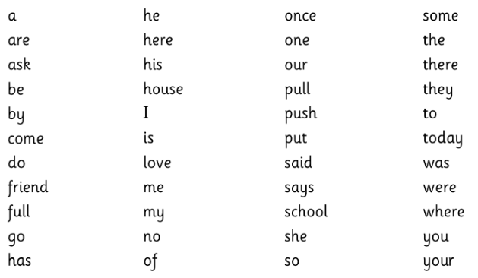  When we spell, we will continue to explore the use of alternative ‘phase five’ graphemes so that we spell with increasing accuracy. We will also be aiming to read and spell all these common exception words correctly.
  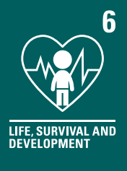 | 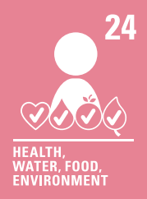 | 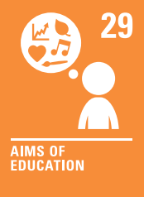
  Ten and a Bit
  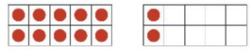
  twelve / ten-two
  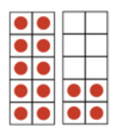 | fourteen / ten-four
   | 4 + 10 = 14  10 + 4 = 14  14 = 10 + 4  14 = 4 + 10 | 14 – 4 = 10  10 – 4 = 14
  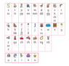 |  |  | 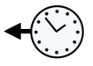
  writing a series of linked sentences. | saying our words aloud to check for any missing sounds. | reading our work with a focus on editing and improving our work. | using past tense.
   |  | 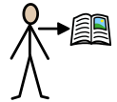 | 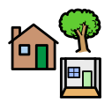
  writing with a clear beginning, middle and end. | using familiar narrative phrases e.g. once upon a time, happily ever after or many years ago. | include characters and simple descriptions. | include simple statements about the setting.
Design Technology – Making Bread | Computing – Programming Animations | History – The Great Fire of London
In Design Technology, this term, we will be designing and making bread, just like the bakers in Pudding Lane. We will be tasting different types of bread, learning about the ingredients used to make them, and discussing how bread is made. We will then design and make our own bread.  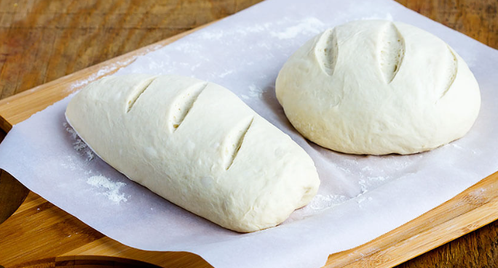 | In Computing, we will be introduced to on-screen programming through ScratchJr. Across the term, we will explore the way a project looks by investigating sprites and backgrounds.  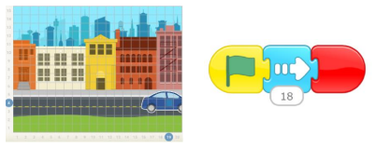  Your child will be learning to;  - make comparisons between ‘Bee-Bot’ programming and programming using ‘ScratchJr’.  - understand what algorithms are, how they are implemented as programs on digital devices, and that programs execute by following precise and unambiguous instructions.  - use logical reasoning to predict the behaviour of simple programs.  - use programming blocks to use, modify and create programs | In History, we will be learning about:  - How did the Great Fire of London start?  - What happened during the Great Fire and how do we know?  - Why did the Great Fire burn down so many houses?  - What could have been done to slow the spread of the fire?  - How did people survive the Great Fire?  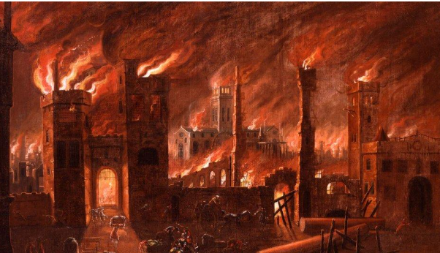  - How should London be rebuilt after the Great Fire
Geography – United Kingdom | Science – Plants | Physical Education – Net and Wall games/ Athletics
In Geography, we will be learning about the United Kingdom (UK).    Your child will be learning to:  - name and locate the four countries and capital cities of the United Kingdom.  - identify key features of the United Kingdom and its four countries.  - use simple compass directions (North, South, East and West) and locational and directional language [for example, near and far; left and right], to describe the location of features and routes on a map. | In Science, we will be discovering the range of wildlife that lives in our gardens, school and town (Swindon).  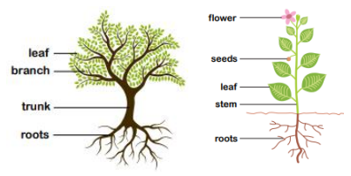  Your child will be learning to;  - identify and name a variety of common wild and garden plants.  - identify and name deciduous (trees that drop their leaves every year) and evergreen trees (trees that keep their leaves all year round).  identify and describe the basic structure of a variety of common flowering plants, including trees. | Net and Wall games  - To defend space using the ready position  - To play against an opponent to score  - To explore hitting with a racket  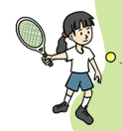  - To develop racket and ball skills  - To develop sending a ball with a racket  - To develop hitting over a net  Athletics  - To move at different speeds  - To develop balance  - To develop changing direction quickly  - To explore hopping, jumping and leaping for distance  - To develop throwing for distance  - To develop throwing for accuracy

Supporting your child at home
Below you will find some optional ways to support your child at home:
Mathematics | Phonics & Reading
White Rose 1-Minute Maths  White Rose provides a ‘1-Minute Maths’ application that can be used to practise number facts or subitising at home. You can download this application scanning these QR codes or via:  https://whiterosemaths.com/1-minute-maths | You can use the link or can the QR code below to find a wide range of information and videos to support your child with their reading and/or Phase 2, 3 and 5 sounds.  For parents | Letters and Sounds (littlewandlelettersandsounds.org.uk)    Your child should read their Little Wandle book to you at least 3 times a week. The more your child reads the more fluent they will become. Please remember to record this in their yellow reading record.  Phonics Play  Phonics Play provides free-access to three games that could be used to practise reading alien (non-sense) words and real words.  You can visit this website by scanning this QR code or via: PhonicsPlay - Resources    Top Marks  Top Marks provides free-access to a range of games that could be used to practise word and sentence reading.  You can visit this website by scanning this QR code or via: Letters and Sounds, English Games for 5-7 Years - Topmarks  
   | App Store |  | Google Play
   |  | 
Computing
ScratchJr is an application that can be used to practise on-screen coding at home. You can download this application scanning these QR codes or via:
ScratchJr - Home
 | App Store |  | Google Play


Handwriting
This term we are going to continue to focus on our capital letters and ensuring that we are correctly forming our lower case letters.
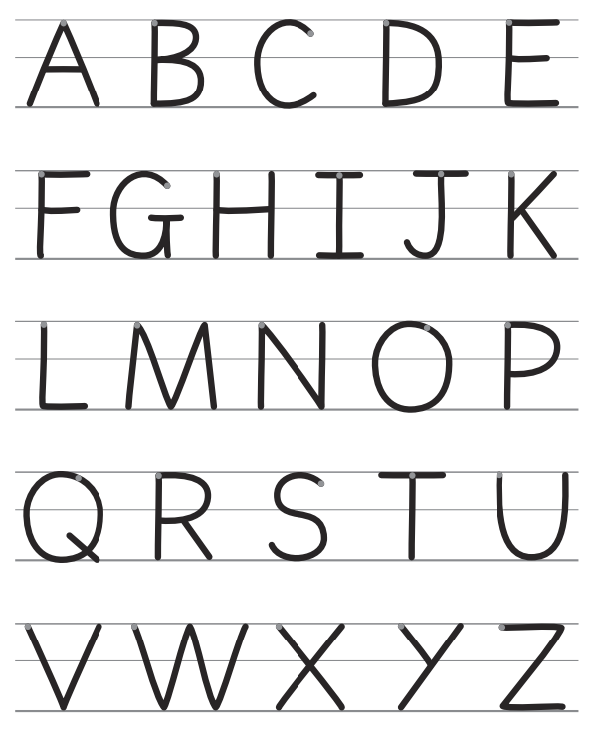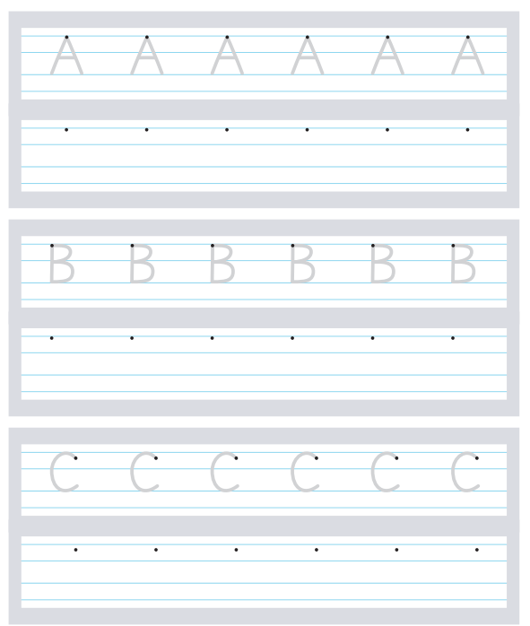

You child could practice their lowercase and upper case letters
using their pupil log-in to .

